Data Structure and Algorithm

Laboratory Activity No. 2

Algorithm Analysis and Flowchart

|  |  |
| --- | --- |
| *Submitted by:* | *Instructor:* |
| Polestico,Paul Justine D. | Engr. Maria Rizette H. Sayo |

August, 02, 2025

# Objectives

Introduction

Data structure is a systematic way of organizing and accessing data, and an algorithm is a step-by-step procedure for performing some task in a finite amount of time. These concepts are central to computing, but to be able to classify some data structures and algorithms as “good,” we must have precise ways of analyzing them.

This laboratory activity aims to implement the principles and techniques in:

* Writing a well-structured procedure in programming
* Writing algorithm that best suits to solve computing problems to improve the efficiency of computers
* Convert algorithms into flowcharting symbols

# Methods

* 1. Explain algorithm and flowchart

-x, x<0

x, x ≥ 0

* 1. Write algorithm to find the result of equation: f (x) = and draw its flowchart
  2. Write a short recursive Python function that finds the minimum and maximum values in a sequence without using any loops

# Results

* 1. Explain algorithm and flowchart

A1. Algorithm

Algorithm, in the context of computer programming, refers to a set of instructions assigned by the user to be executed by a computer to perform specific tasks with efficiency and precision.

Example:

A python program that calculates the area of a circle.

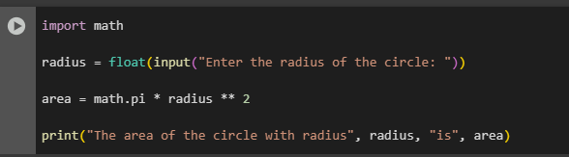

Figure 1 Screenshot of program

A2. Flowchart

Flowchart, are graphical representations of data, algorithms, or processes that provide a visual approach to understanding code. They are used to demonstrate the flow of the program and its processesses for comprehensive planning and development of such.

Example:

A flowchart of the program that calculates the area of a circle.

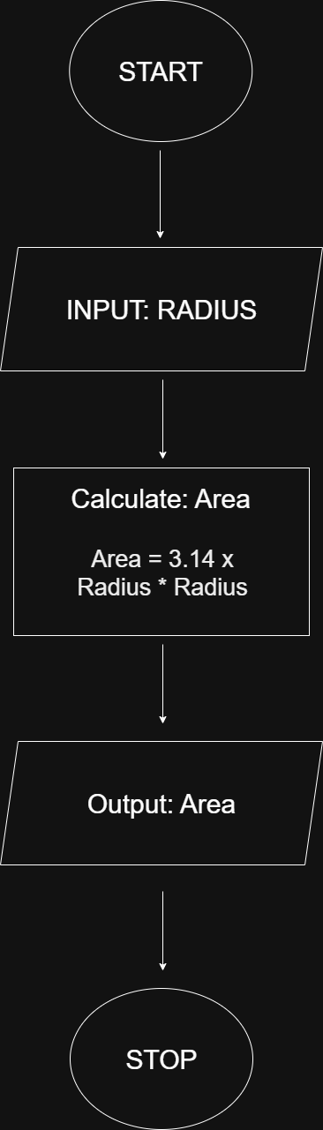

Figure 2 Flowchart of program

B. Piecewise Function

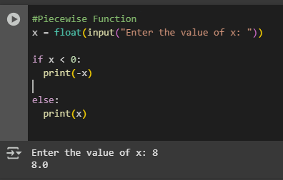

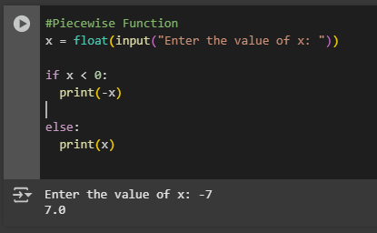

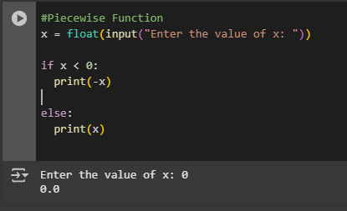

Figure 3 Screenshot of Piecewise Function

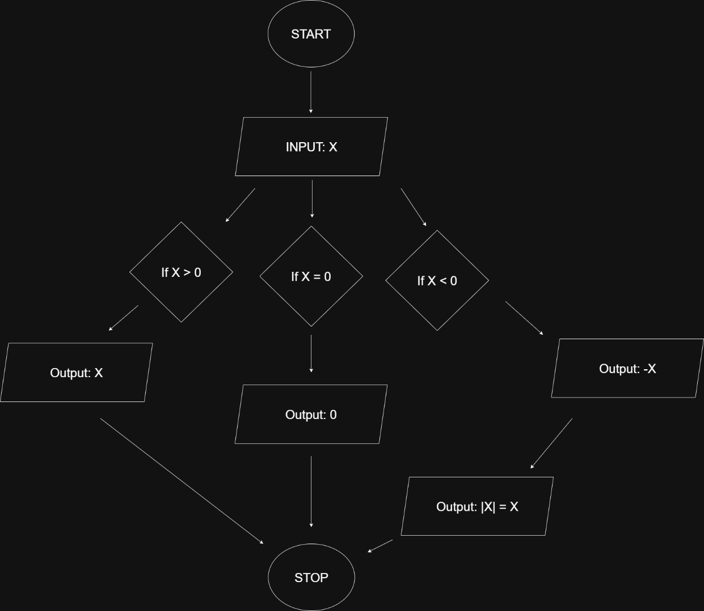

Figure 4 Flowchart of Piecewise Function

A piecewise function is a function f(x) that has different definitions or rules

depending on the interval of the input x. In other words, the function behaves differently over different parts of its domain.

For example, if a function is defined with two different expressions, its graph may open or change direction in different ways depending on which expression applies.

A common example of a piecewise function is the **absolute value function**. This function turns all negative inputs into positive outputs. That’s because it uses one rule when x is negative (it changes the sign), and a different rule when x is positive or zero (it keeps the value the same). This makes the absolute value function a type of piecewise function.

1. Recursive Python Function

Recursion refers to a function that calls itself to solve a problem by breaking it down into simpler and more manageable parts. In this function,it finds the minimum and maximum values in a sequence without the usage of loops.

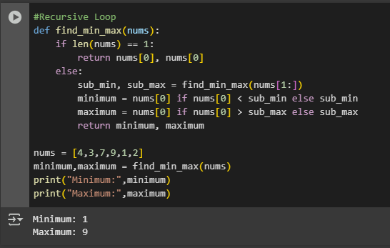

Figure 5 Screenshot of Recursive Python Function

# Conclusion

Algorithms and Flowcharts work together to provide a comprehensive and efficient way of developing and modifying programs. Functions such as the Recursive Function help in providing proficiency required for quick computing. Flowcharts demonstrate the importance of visual presentation in debugging,understanding,and communication of ideas. They form a strong foundation for effective software development.

**References**

[1] Co Arthur O.. “University of Caloocan City Computer Engineering Department Honor Code,” UCC-CpE Departmental Policies, 2020.

[2] GeeksforGeeks, “What is an Algorithm | Introduction to Algorithms,” *GeeksforGeeks*, Jul. 11, 2025. <https://www.geeksforgeeks.org/dsa/introduction-to-algorithms/> (accessed August 2,2025)

[3] GeeksforGeeks, “What is a Flowchart and its Types?,” *GeeksforGeeks*, Apr. 07, 2025. <https://www.geeksforgeeks.org/computer-science-fundamentals/what-is-a-flowchart-and-its-types/> (Accessed August 2,2025)

[4[“Piecewise function - how to graph? examples, evaluating,” *Cuemath*. <https://www.cuemath.com/calculus/piecewise-function/> (Accessed August 2,2025)

[5]GeeksforGeeks, “Recursion in Python,” *GeeksforGeeks*, Jul. 15, 2025. <https://www.geeksforgeeks.org/python/recursion-in-python/> (Accessed August 2,2025)